**A Website for Women Empowerment.**

This project basically focuses on what digital solution can we provide to empower an unprivileged woman.

For making this website, technology that I have used is Node.js for backend and MongoDB for databases. For Frontend I have used HTML, CSS, BOOTSTRAP & JAVASCRIPT.

This is the landing page of the website.

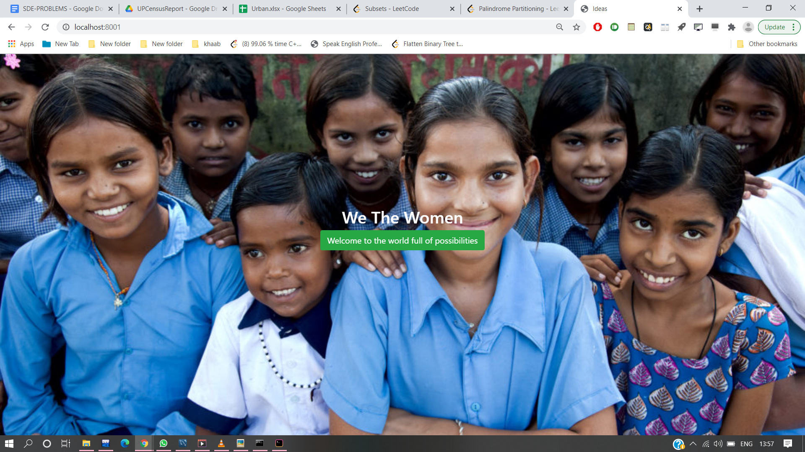

The main take away from this web application are :

1. For Accessing all these Features of this website, We have introduced a Signup/login portal.

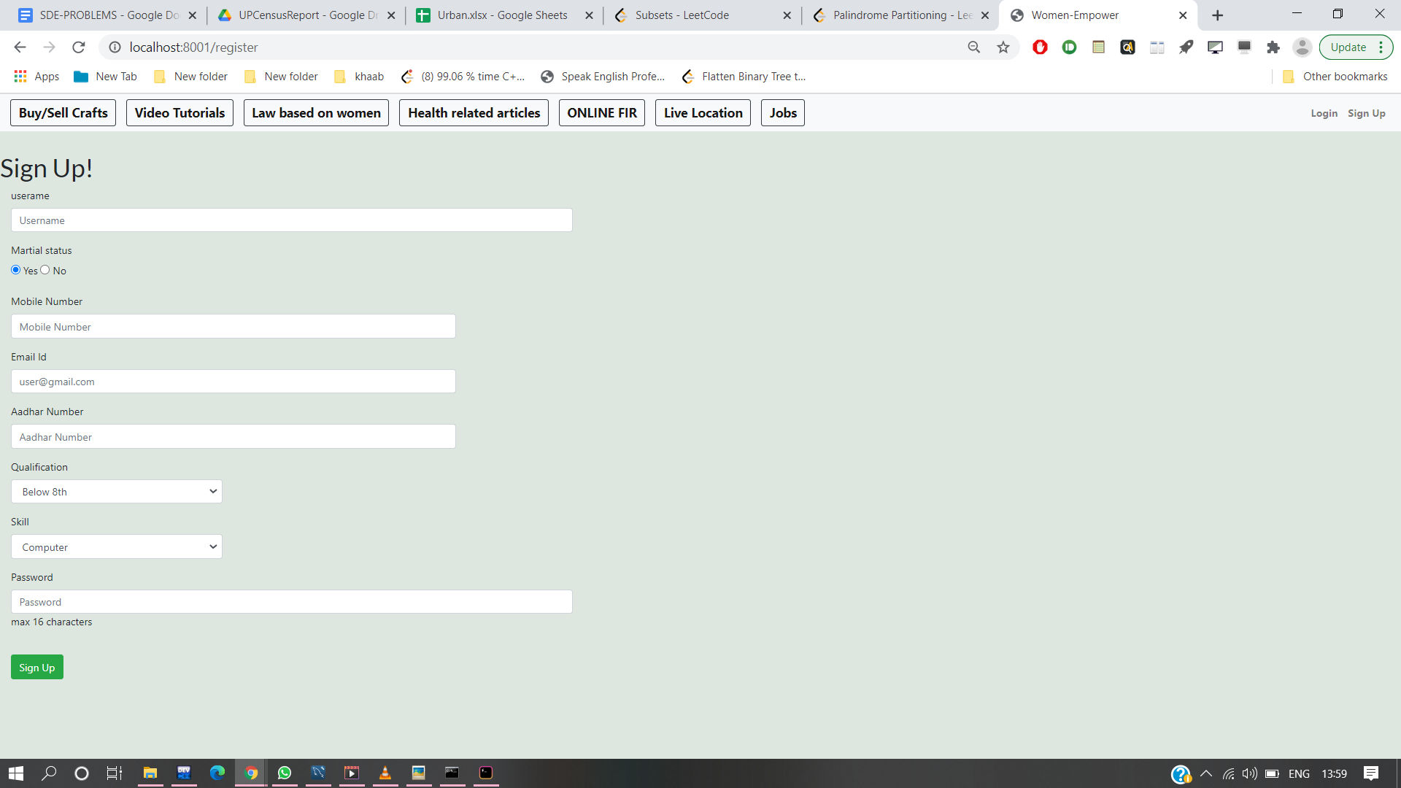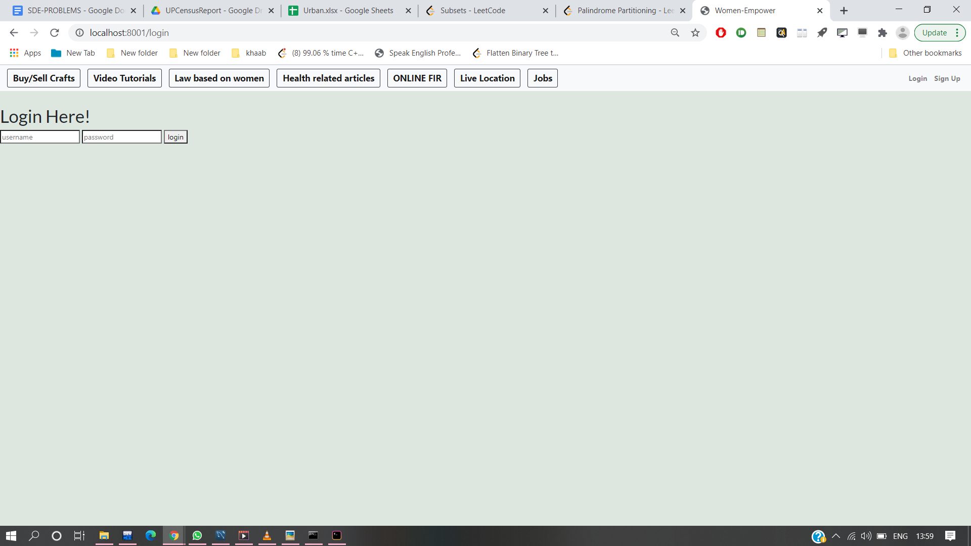

2. Online Shopping for Handmade things, in which anyone can buy or sell anything . For payment We have provided two modes that are Cash On Delivery & Online Payment like UPI(Paytm), credit Card, Debit Card.

For Online payment via Paytm I have used the payment gateway of Paytm with the help of Node.js framework.

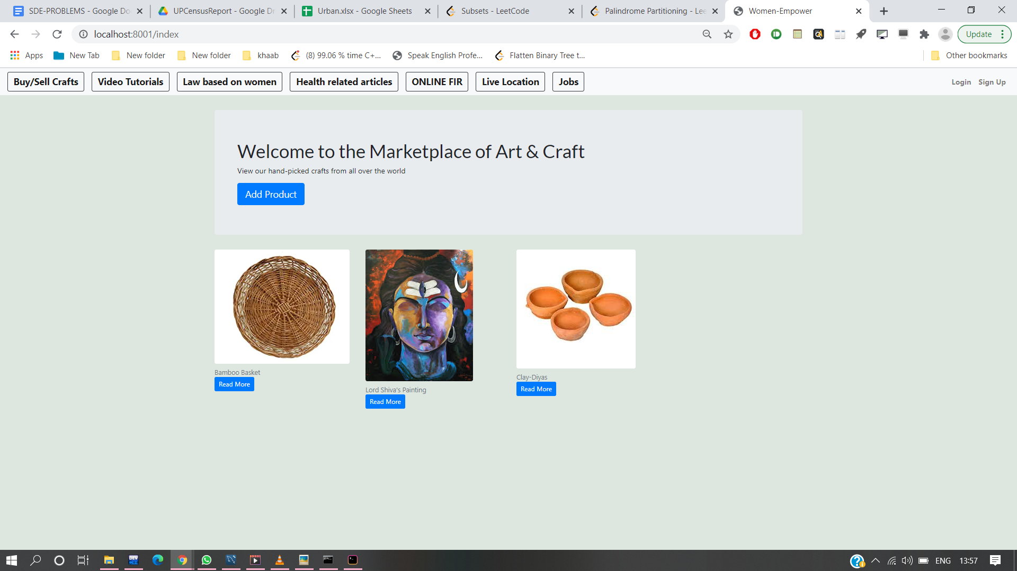

3. For safety purposes, There is a panic button i.e When you will click that button then automatically a mail with your location will be sent from your Registered Email Id to your Relatives or parents email Id which we have already taken at the time of signup.

For fetch current location use geolocation api.which will provide latitude and longitude of current position after that we attach with base url of maps and send to the relative and friend.

For sending Mail I have used the Nodemailer module.

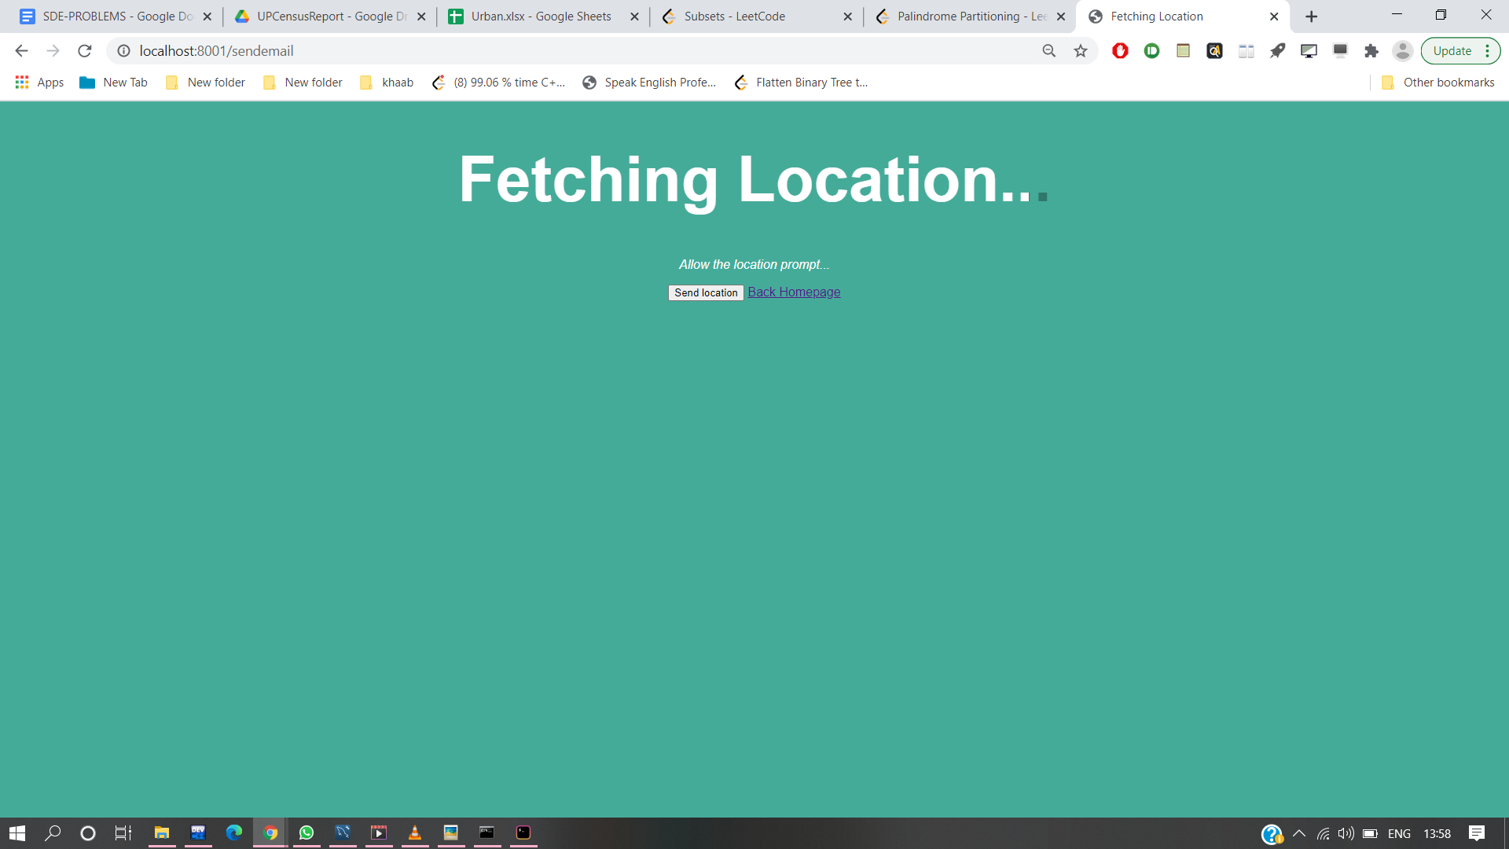

4. We have provided a feature for improving one's skill or if one wants to learn new stuff like Knitting ,Painting, Making some Handmade things etc. through Online tutorial classes.

Also we have given a job portal like on this there is data of all vacancies has given.They can directly Apply through this Portal searching the job according to their skills.

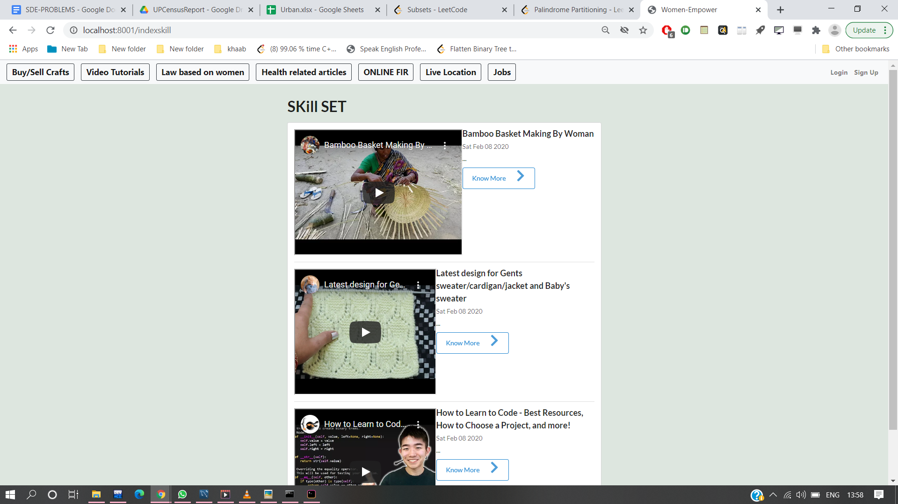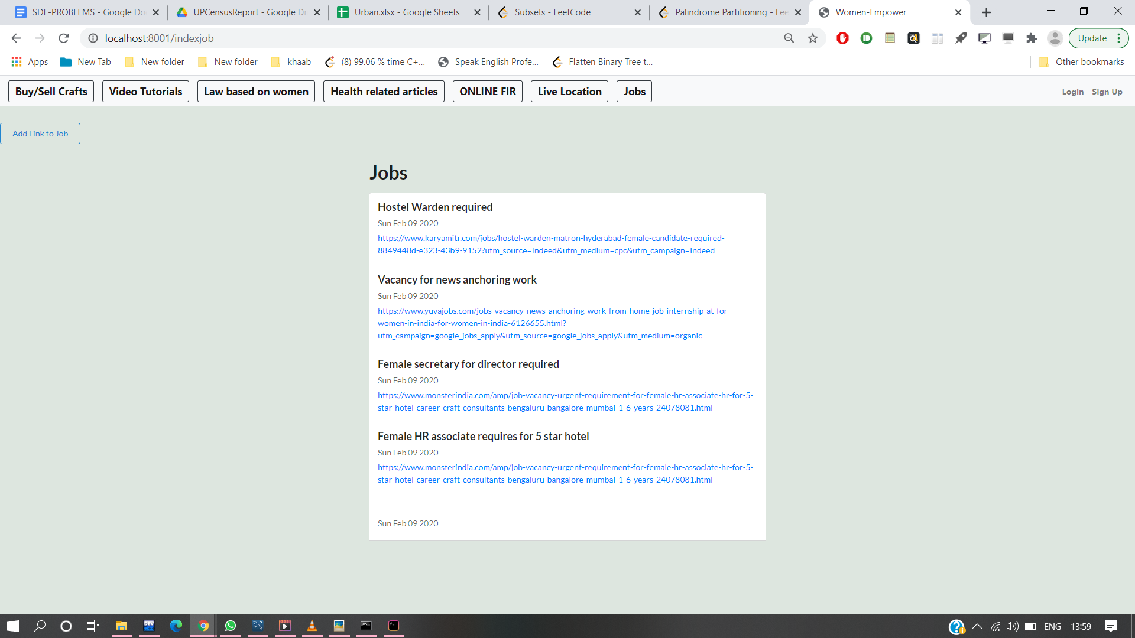

5. Most of the Women that don't know about Their Rights and law based on women, for which we have provided some law and rights which have been taken from the government database and a woman can file FIR by just filling up the basic information.

Before filing the FIR we will verify the user to cross-check if the user isn't some bot via OTP that will be sent on their Registered Email Id.

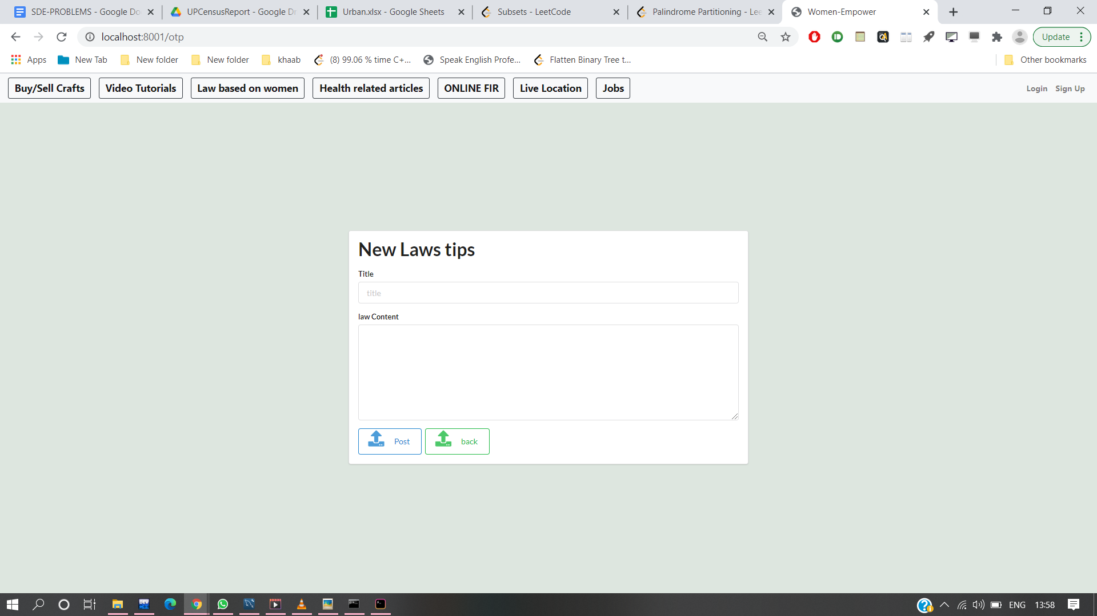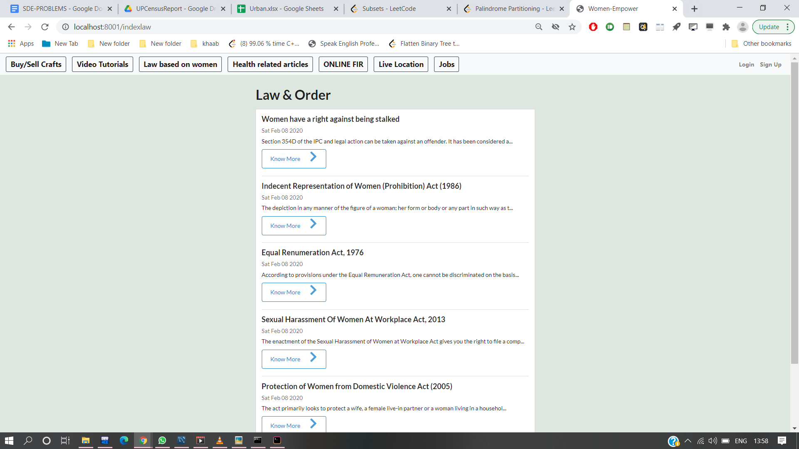

6. In our Indian society women are less discussed. So we have provided the website with an open forum where anyone can write an article related to women's health/diet or taboos and submit it for anyone to read.

